**CRM Application For Jewel Management**

**College Name: Shree Venkateshwara College of Arts & Science**

**College Code : brubd**

**TEAM ID : NM2025TMID20903**

**TEAM MEMBERS :**

**Team LeaderName: N. Sahana**

**Email:** [**sahana2023cs@gmail.com**](mailto:sahana2023cs@gmail.com)

**Team Member : K. Kanjana Devi**

**Email:** [**kanjanadevik2023@gmail.com**](mailto:kanjanadevik2023@gmail.com)

**Team Member : R. Anu**

**Email:** [**anur2023cs@gmail.com**](mailto:anur2023cs@gmail.com)

**Team Member : S. Rakshana**

**Email:** [**rakshanas2023cs@gmail.com**](mailto:rakshanas2023cs@gmail.com)

**Table of Contents**

1. Project Introduction

2. Salesforce Developer Edition Account Setup

3. Project Workspace and Course Navigation

4. Creating Salesforce Custom Objects

5. Defining and Adding Fields in Objects

6. Creating Relationships Between Objects

7. Creating Custom Tabs

8. Configuring Lightning Application

9. Managing Profiles and Roles

10. Creating Users and Assigning Profiles and Roles

11. Creating Page Layouts and Record Types

12. Creating Permission Sets

13. Implementing Validation Rules

14. Implementing Field Dependencies

15. Creating Apex Triggers and Classes for Automation

16. Data Entry (User Adoption)

17. Creating Reports and Dashboards

18. Implementing Flows for Automation

19. Preparing Project Documentation

20. Recording Project Demo Video

21. Project Submission Guidelines

22. Troubleshooting Common Issues

23. Summary and Future Scope

* **Project Introduction**

This project aims at developing a Customer Relationship Management (CRM) application tailored for Jewel Management using Salesforce platform features. It introduces designing an end-to-end CRM system with functionalities to manage customers, items (jewellery pieces), orders, pricing, and billing. Automation via Apex triggers and Flows, reporting, and dashboards are also incorporated. This guide walks through all milestones required to complete the project using Salesforce Developer Edition and the NM portal workflow.

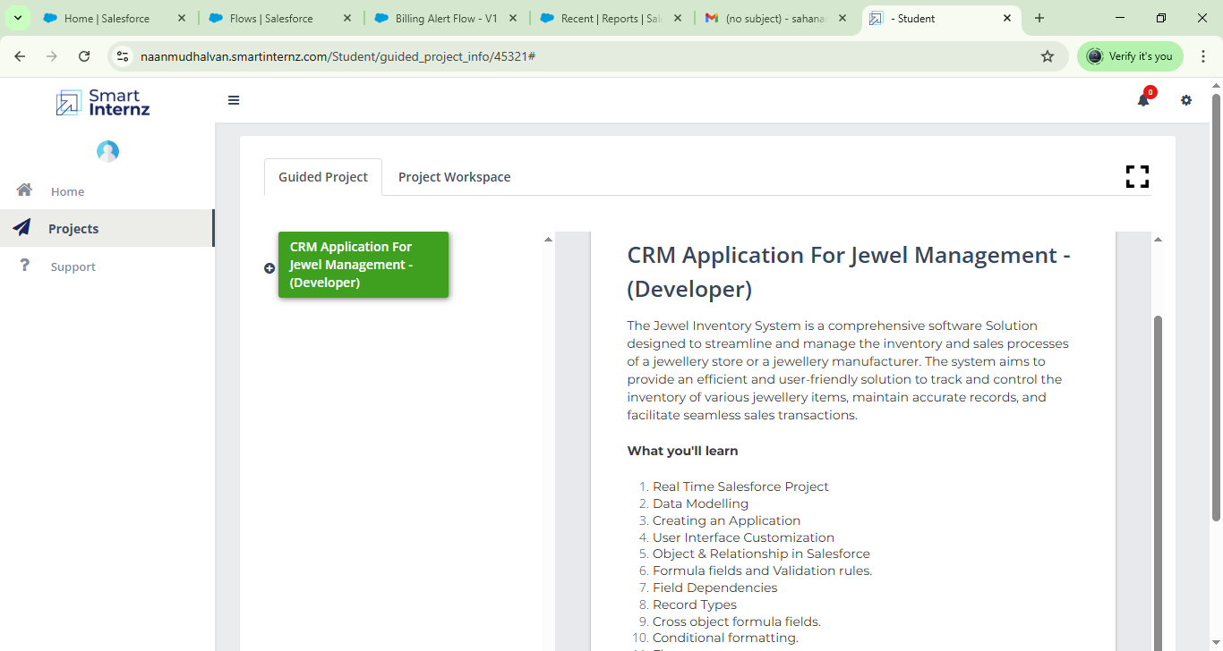

2.**Salesforce Developer Edition Account Setup**

- Go to the Salesforce Developer Edition signup URL (provided in project resources).

- Register with your email, fill in details, and submit signup form.

- Check email for activation link and verify your account.

- Once activated, log in with your credentials to access the Salesforce Developer environment.

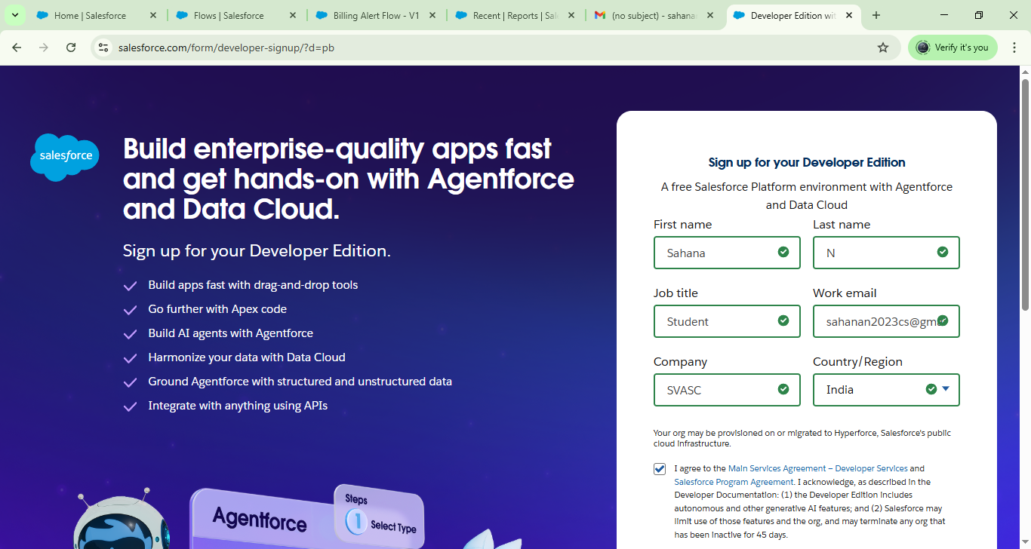

**3. Project Workspace and Course Navigation**

- The project workspace within NM portal provides stepwise guided milestones:

  - Account creation and activation

  - Object creation

  - Tabs and Lightning App setup

  - Profiles, roles, and permission sets

  - Validation rules and field dependencies

  - Apex automation

  - Reports and dashboards

  - Flows and user adoption

- The progress of each milestone can be tracked by moving task cards from backlog to review.

**4. Creating Salesforce Custom Objects**

- Navigate to **Setup > Object Manager**.

- Click **Create > Custom Object**.

- Create the following objects with labels and API names:

  | Object Label     | API Name             | Description                        |

  |------------------|----------------------|----------------------------------|

  | Jewel Customer   | Jewel_Customer__c     | Stores customer details          |

  | Item             | Item__c                | Stores jewel items details       |

  | Customer Order  | Customer_Order__c     | Stores customer orders           |

  | Price          | Price__c              | Stores pricing data              |

  | Billing          | Billing__c            | Stores billing and transaction info |

**5. Defining and Adding Fields in Objects**

Jewel Customer Fields

- Customer Name (Text)

- City (Text)

- Country (Text)

- State (Text)

- Street (Text)

- Postal Code (Text)

- Phone (Phone)

- Email (Email)

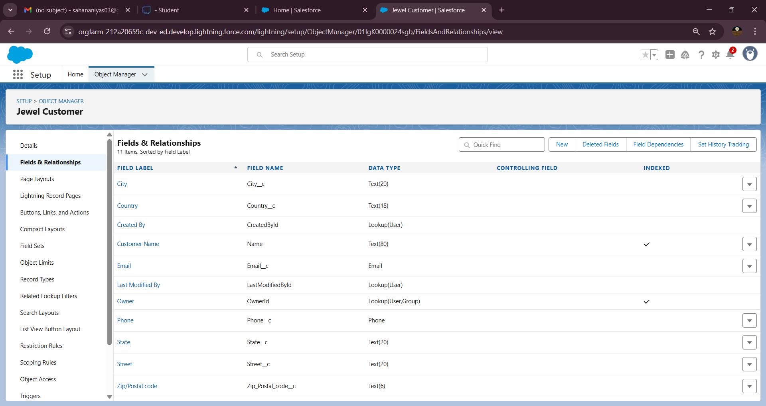

Item Fields

- Item ID (Text/Auto Number)

- Item Type (Picklist) [Gold, Silver]

- Purity (Number)

- Gold Price (Currency)

- Weight (Number)

- Ornaments (Text)

- Priority (Picklist) [Critical, High, Medium, Low]

- Expected Days of Return (Picklist)

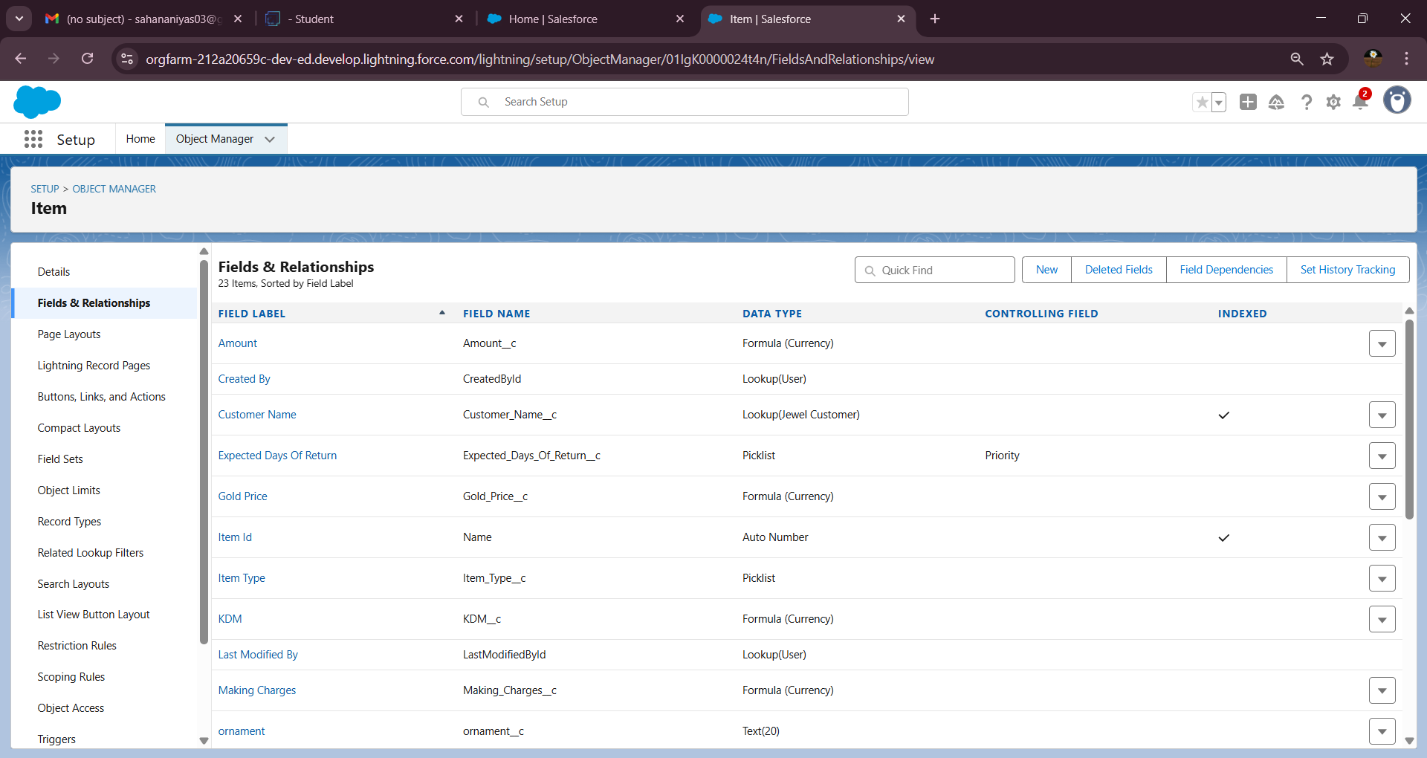

Price Fields

- Gold Price (Currency)

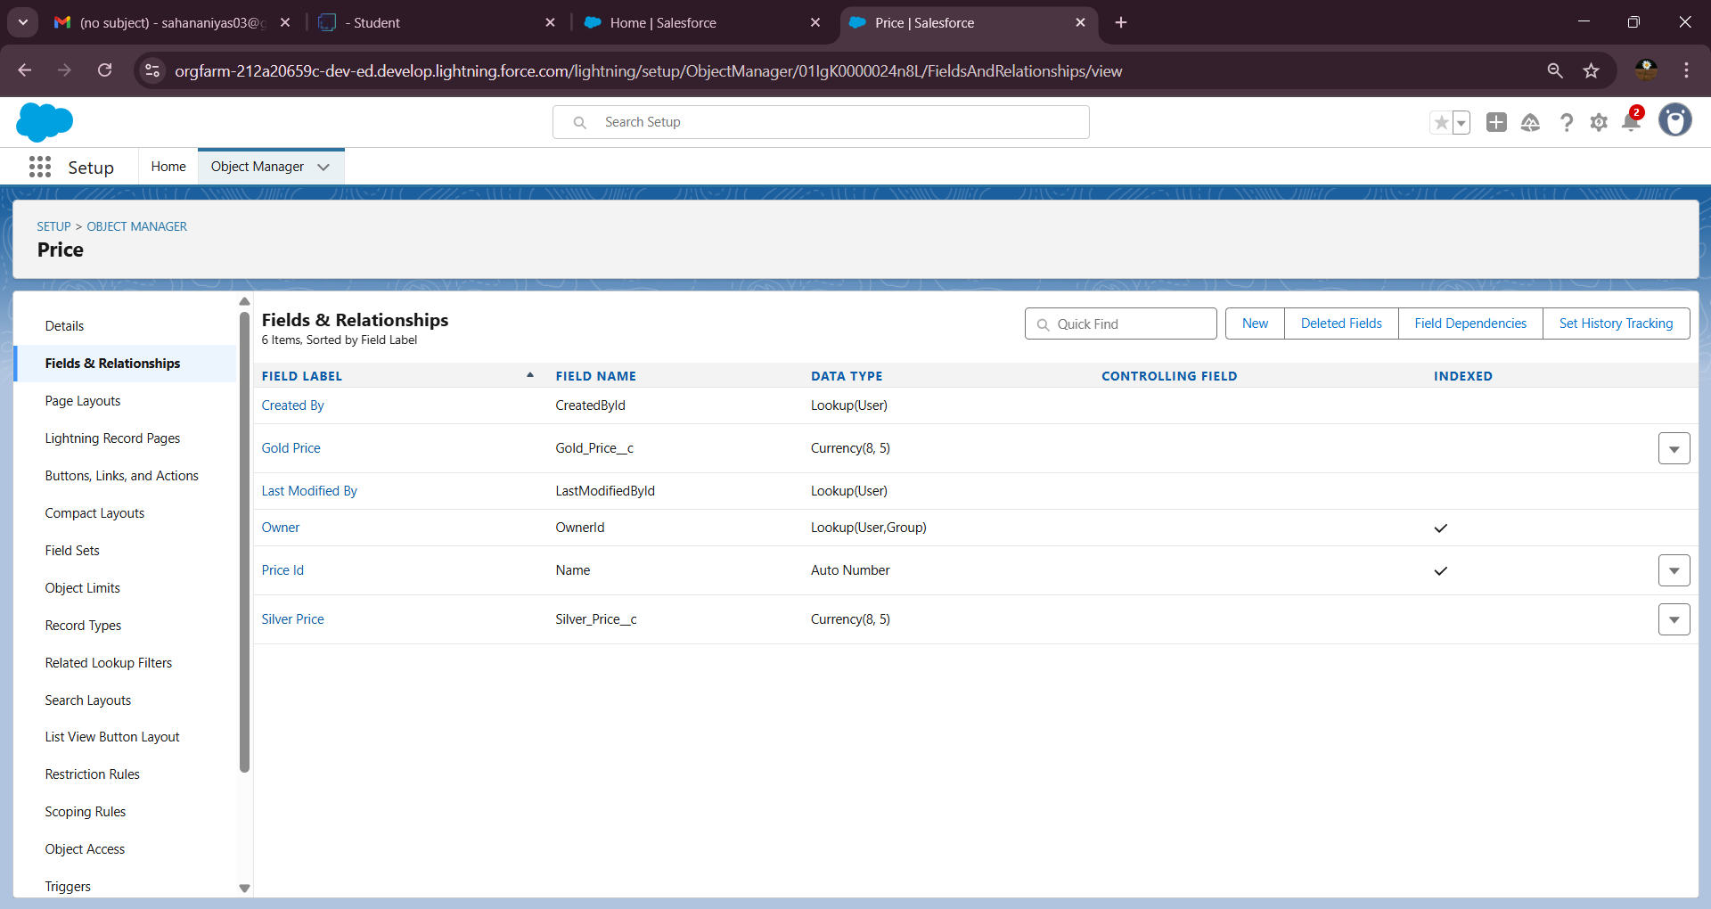

Customer Order Fields

- Order Number (Text/Auto Number)

- Order Date (Date)

- Customer Lookup (Lookup to Jewel Customer)

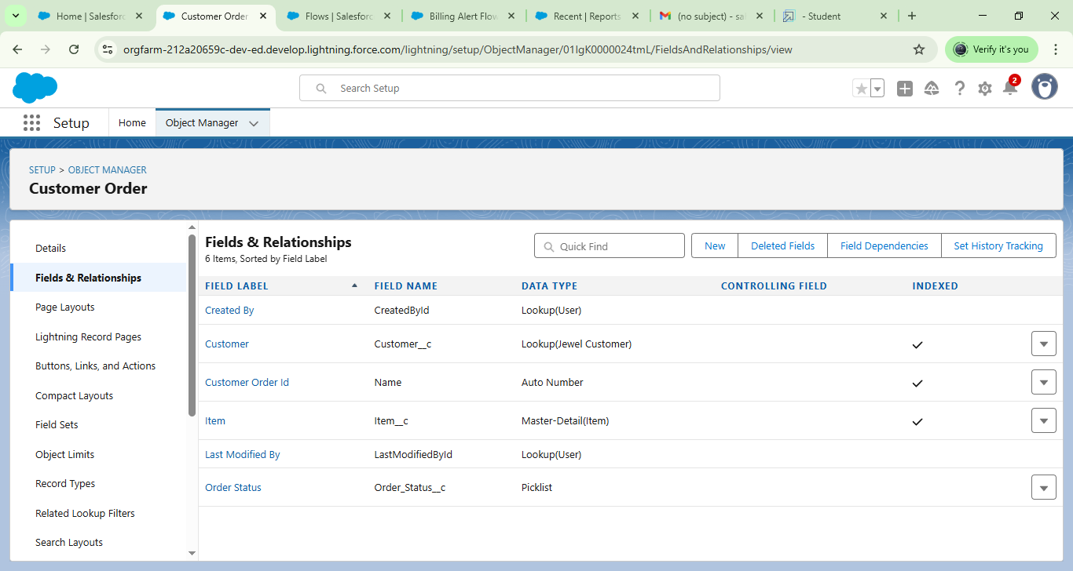

Billing Fields

- Billing Number (Text)

- Paid Amount (Currency)

- Paying Amount (Currency)

**6. Creating Relationships Between Objects**

- In **Customer Order**, create a **Lookup Relationship** with **Jewel Customer**.

- In **Customer Order**, create a **Master-Detail Relationship** with **Item**.

- In **Item**, create a **Lookup Relationship** with **Price**.

- These relationships enable linking orders to customers, items to orders, and prices to items.

**7. Creating Custom Tabs**

- Go to **Setup > Tabs > Custom Object Tabs**.

- Create new tabs for each custom object: Jewel Customer, Item, Customer Order, Price, Billing.

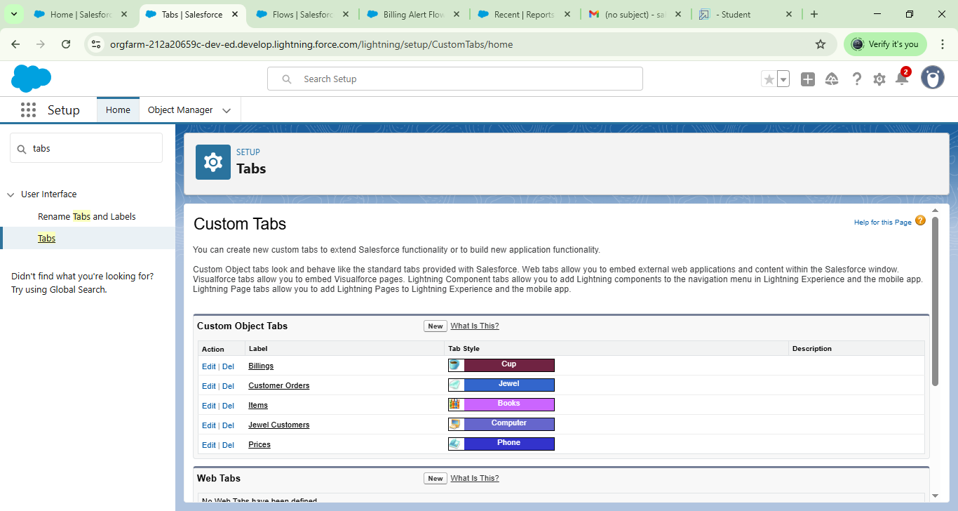- Choose tab styles logically to help with navigation.

**8. Configuring Lightning Application**

- Navigate to **App Manager**.

- Create a new **Lightning App** named "Jewellery Inventory System".

- Add all custom object tabs created above to the app.

- Set app profiles for Goldsmith, Worker, and System Administrator.

- Activate the app for these profiles.

**9. Managing Profiles and Roles**

- Clone **System Administrator** profile to create two custom profiles: **Goldsmith** and **Worker**.

- Adjust custom object permissions appropriately (Read, Create, Edit).

- Define roles:

- Goldsmith role reporting to CEO.

- Worker role reporting to Goldsmith.

- Assign roles to appropriate users.

**10. Creating Users and Assigning Profiles and Roles**

- Create users such as Nicholas Michaelson (Goldsmith role/profile) and Cole Michaelson (Worker role/profile).

- Use valid emails and unique usernames.

- Assign roles and profiles during user creation.

**11. Creating Page Layouts and Record Types**

- Create two page layouts for **Item** object: **Gold Layout** and **Silver Layout**.

- Remove fields unrelated to each layout type (e.g., gold-specific fields removed from silver layout).

- Create record types named **Gold** and **Silver**.

- Assign the record types to respective profiles and link appropriate page layouts.

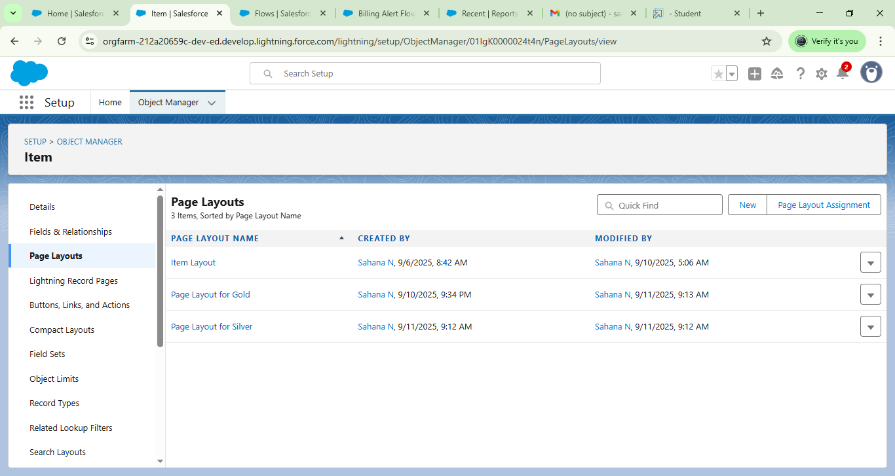

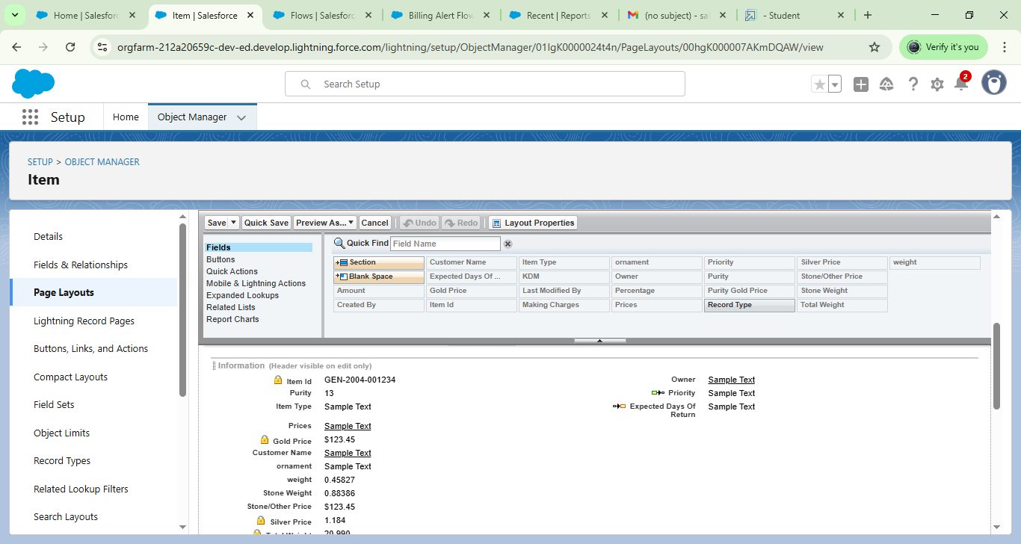

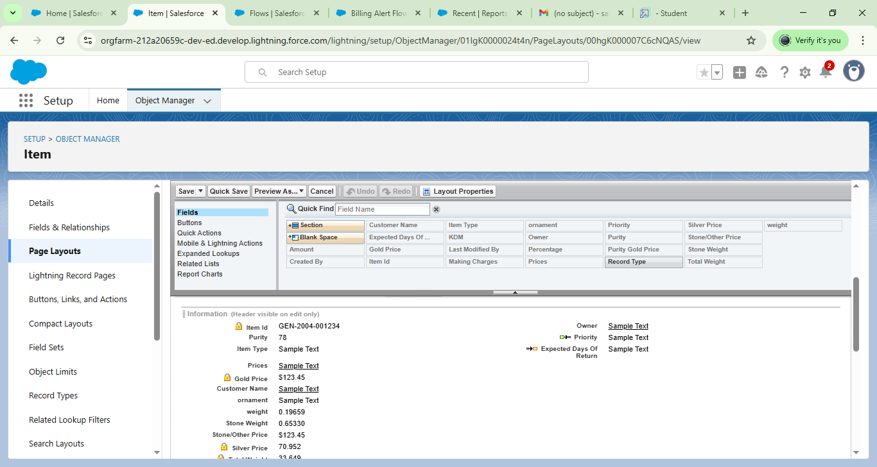

**12. Creating Permission Sets**

- Create permission set named **Permission to Work**.

- Enable object permissions including read, create, edit for applicable objects.

- Assign record types **Gold** and **Silver** to permission set.

- Assign permission set to Worker users.

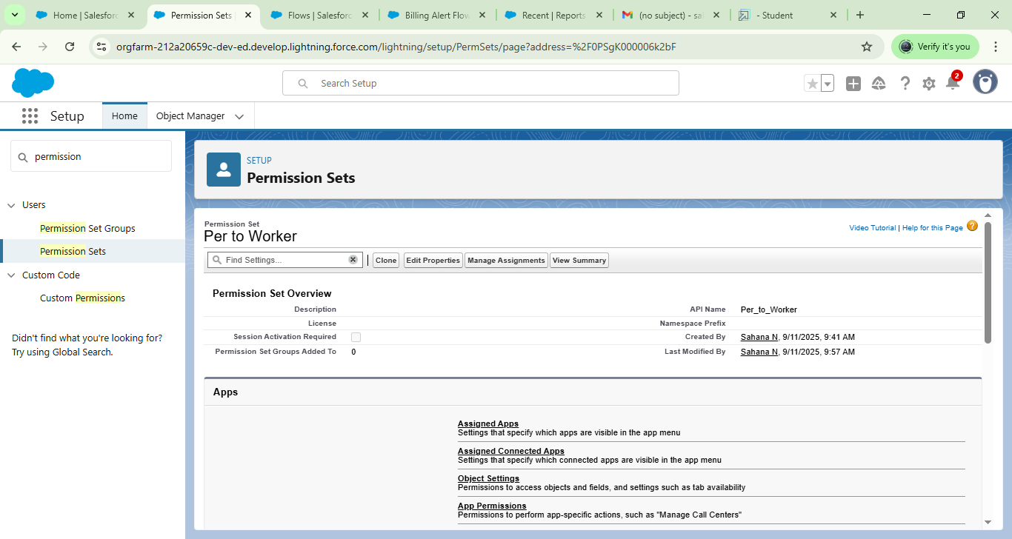

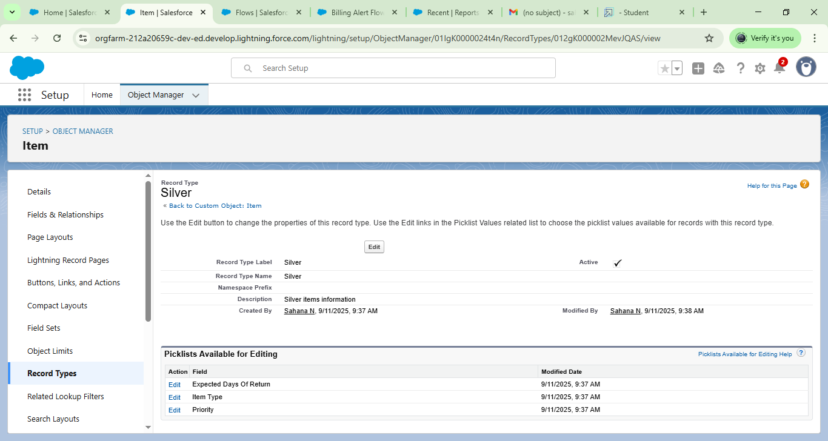

**13. Implementing Validation Rules**

- Create validation rules to enforce data integrity, e.g.:

- Postal Code must be numeric.

- Phone numbers within valid lengths.

- Add proper error messages guiding user input.

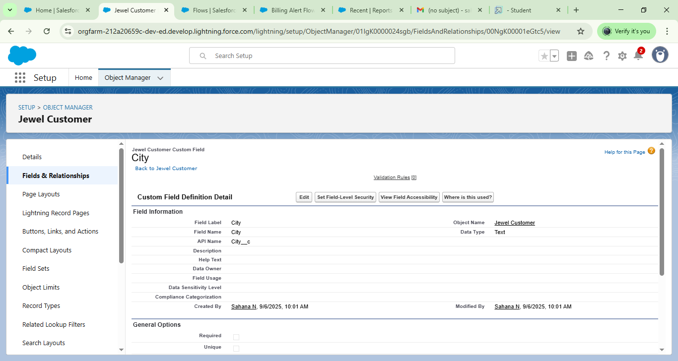

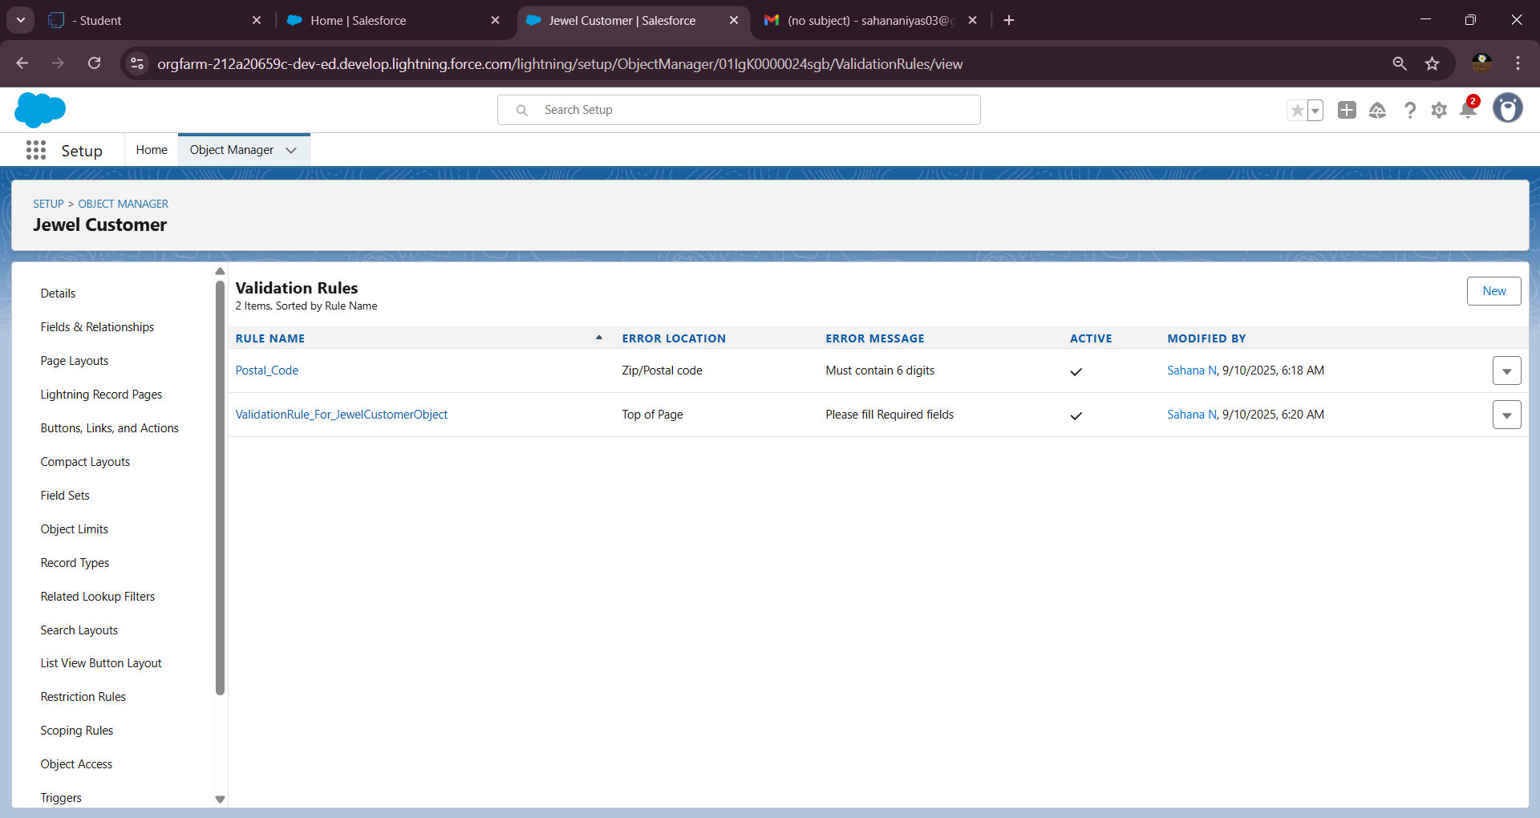

**14. Implementing Field Dependencies**

- Set up dependency for **Priority** field controlling **Expected Days of Return** picklist in **Item**.

- Map priorities to appropriate return days ranges:

  - Critical = 1-3 days

  - High = 2-5 days

  - Medium = 6-7 days

  - Low = 5-8 days

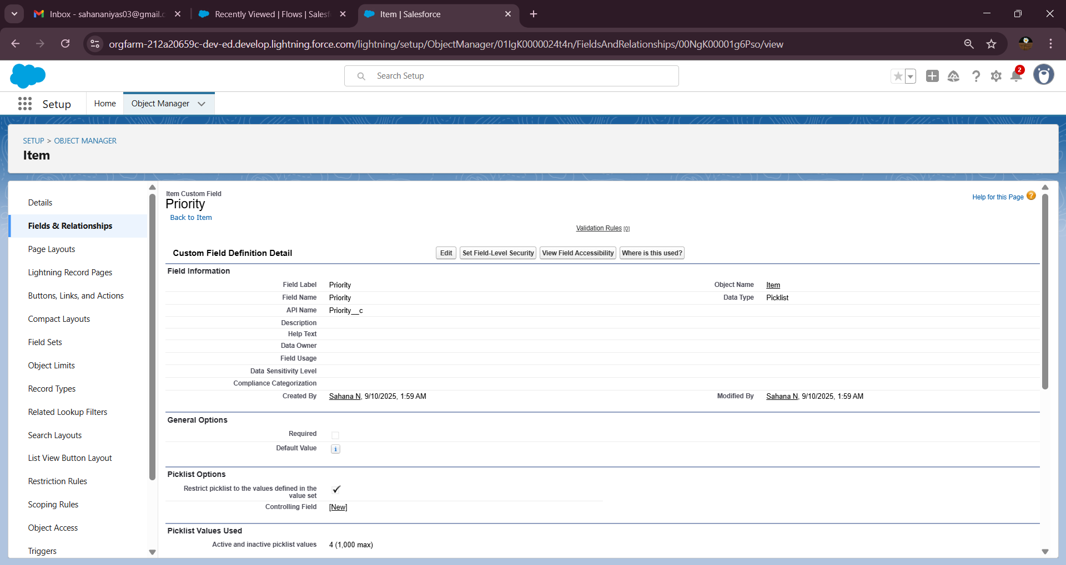

**15. Creating Apex Triggers and Classes for Automation**

- Develop an Apex Class handler for Billing calculations.

- Create Apex Trigger on Billing object:

- Before Insert and Before Update events.

- Ensure all referenced fields in Apex exist (Paid Amount, Paying Amount).

- Save and test trigger with sample data.

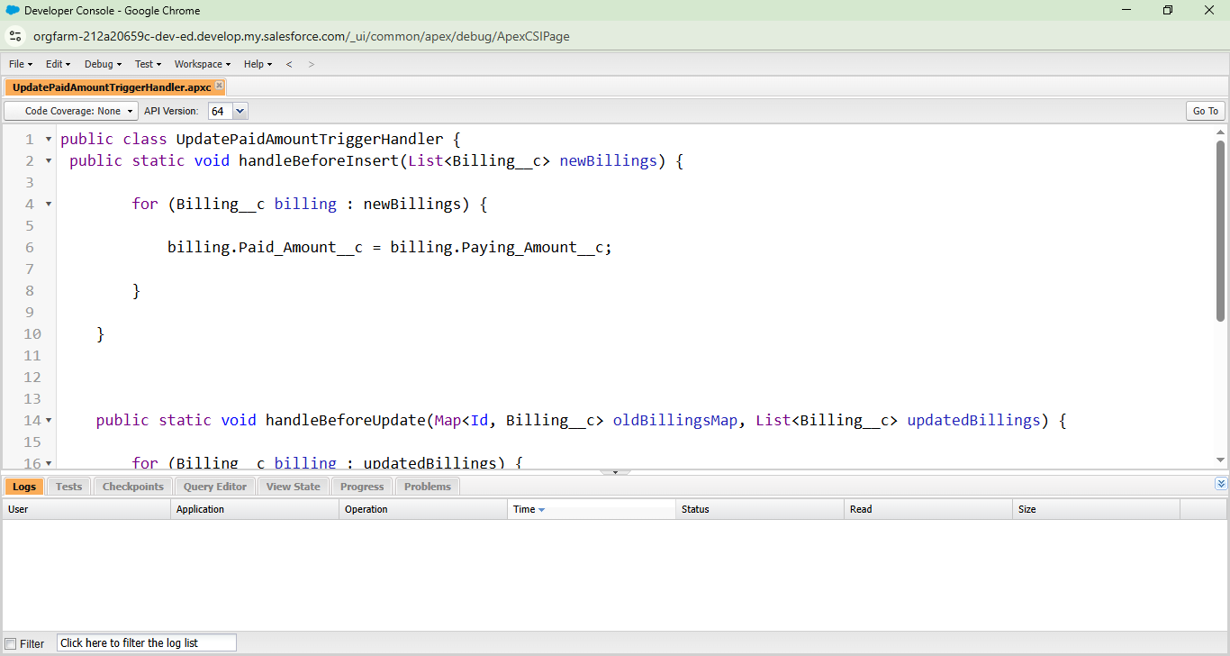

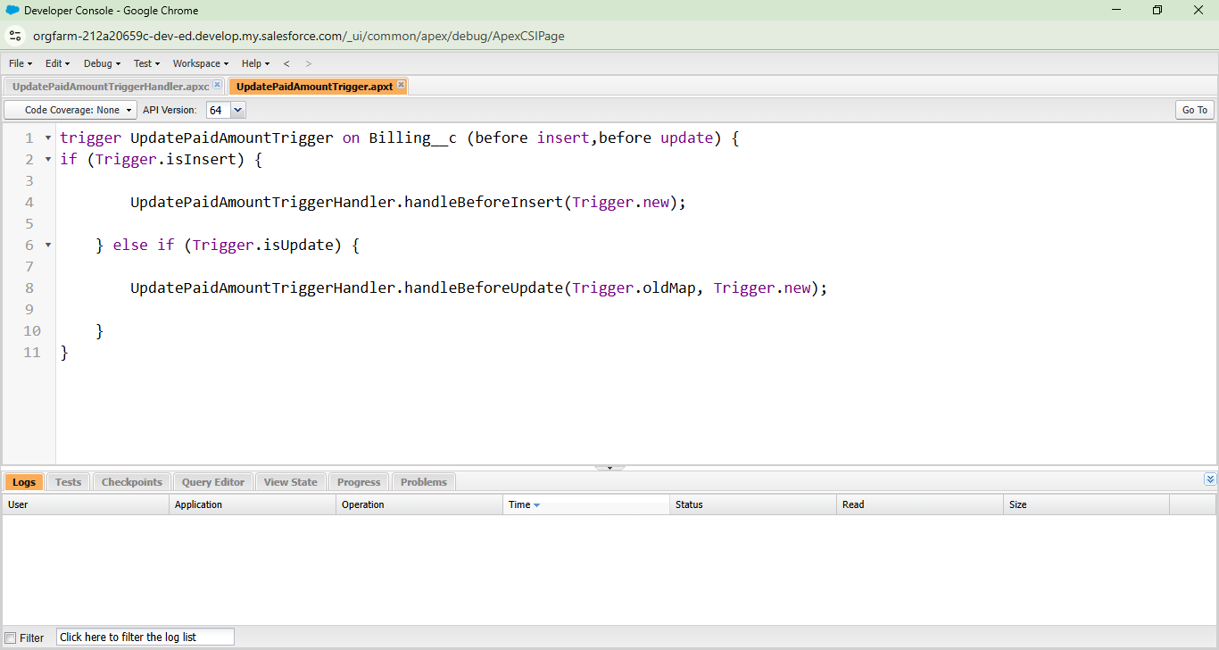

**16. Creating Reports and Dashboards**

- Create reports such as **Price Report**, **Billings with Item Report**.

- Build dashboards to visualize report data:

 - Use widgets: tables, charts, summaries.

- Save and run reports to verify correctness.

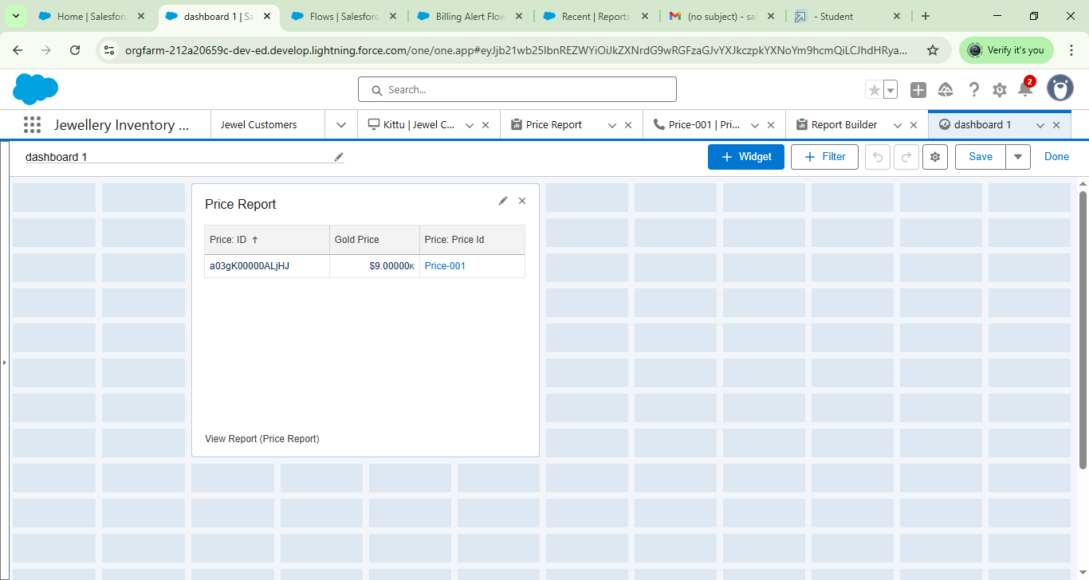

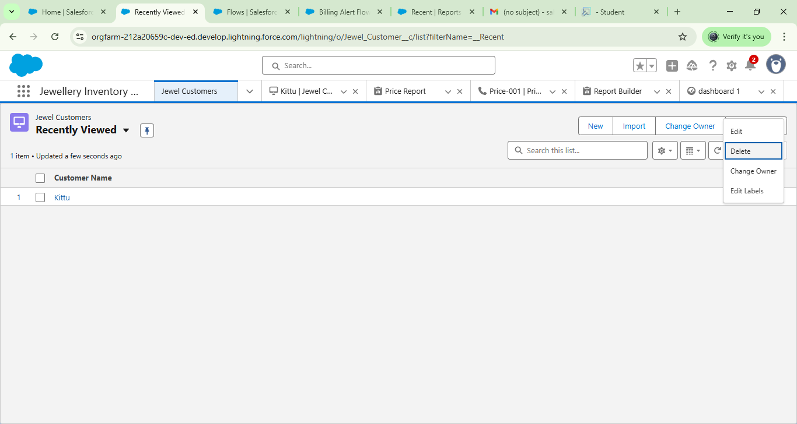

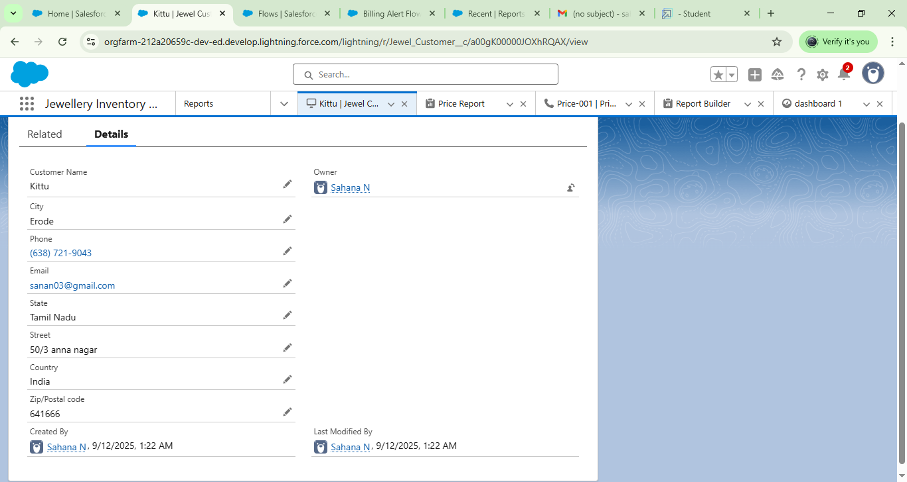

**17. Implementing Flows for Automation**

- Create a **Record-Triggered Flow** on Billing object (when record created/updated).

- Add Text Template for email body.

- Add Send Email action pointing to customer email.

- Activate flow, test email notifications.

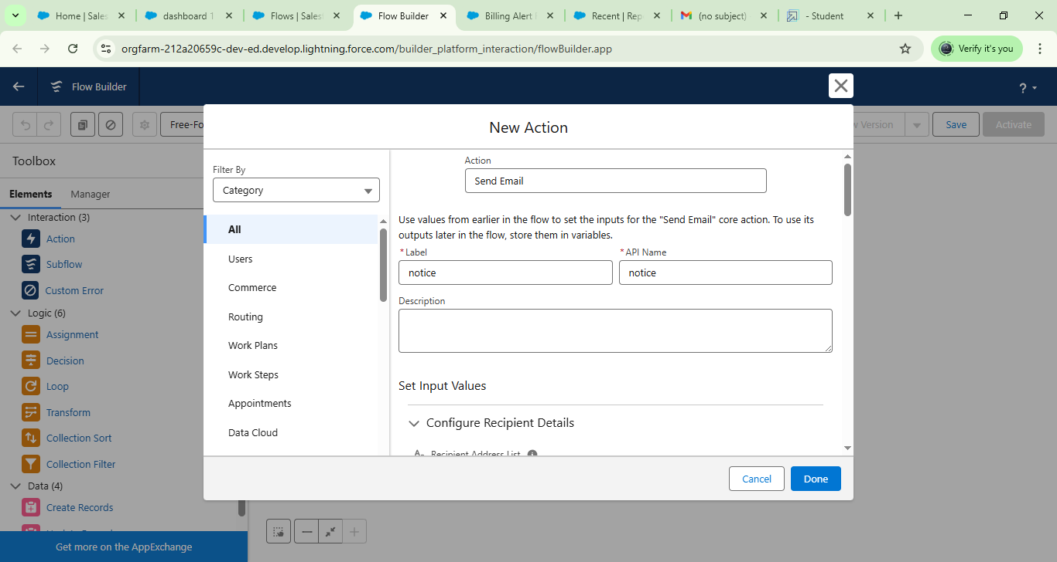

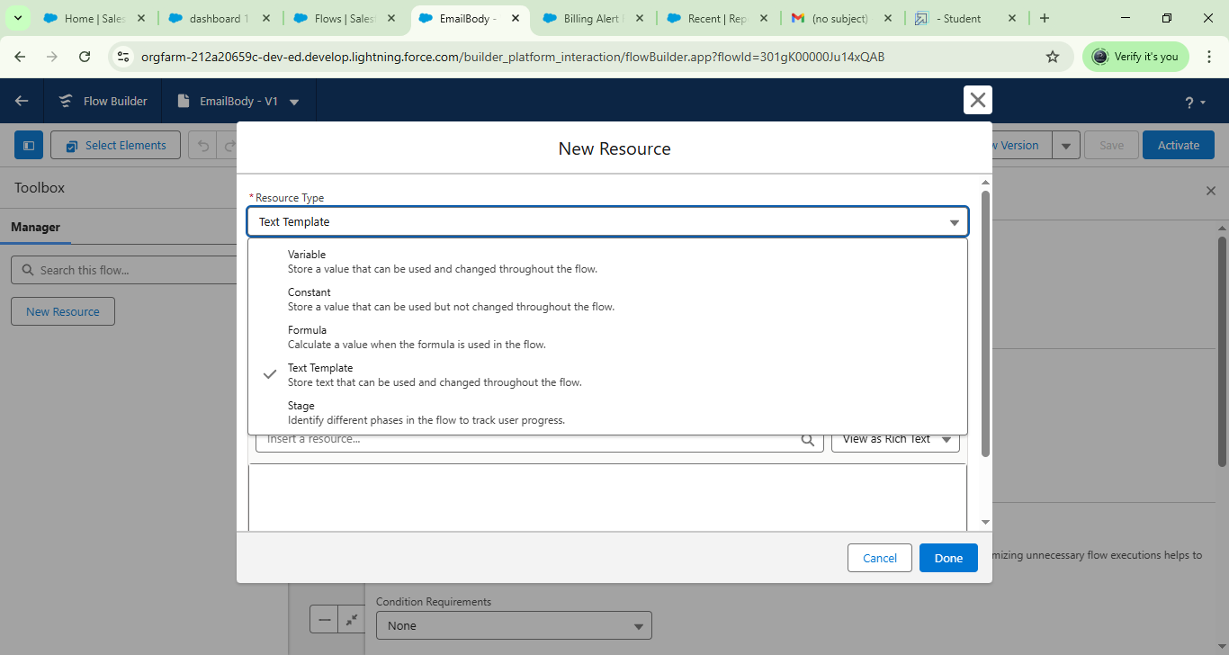

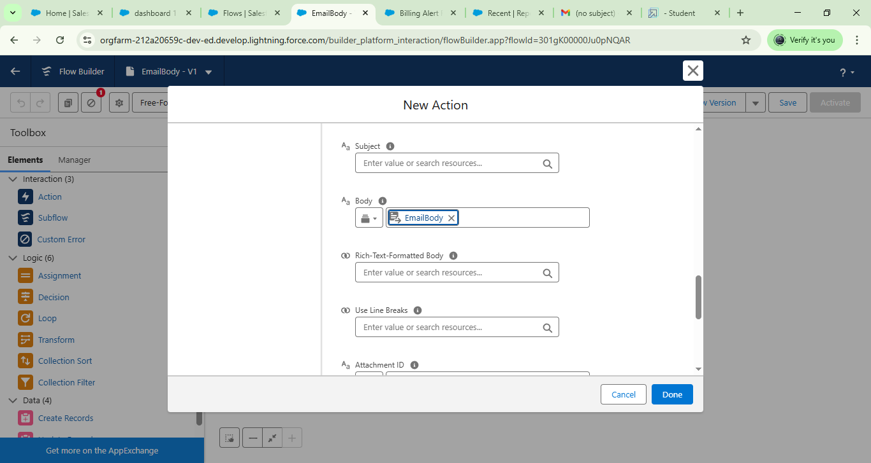

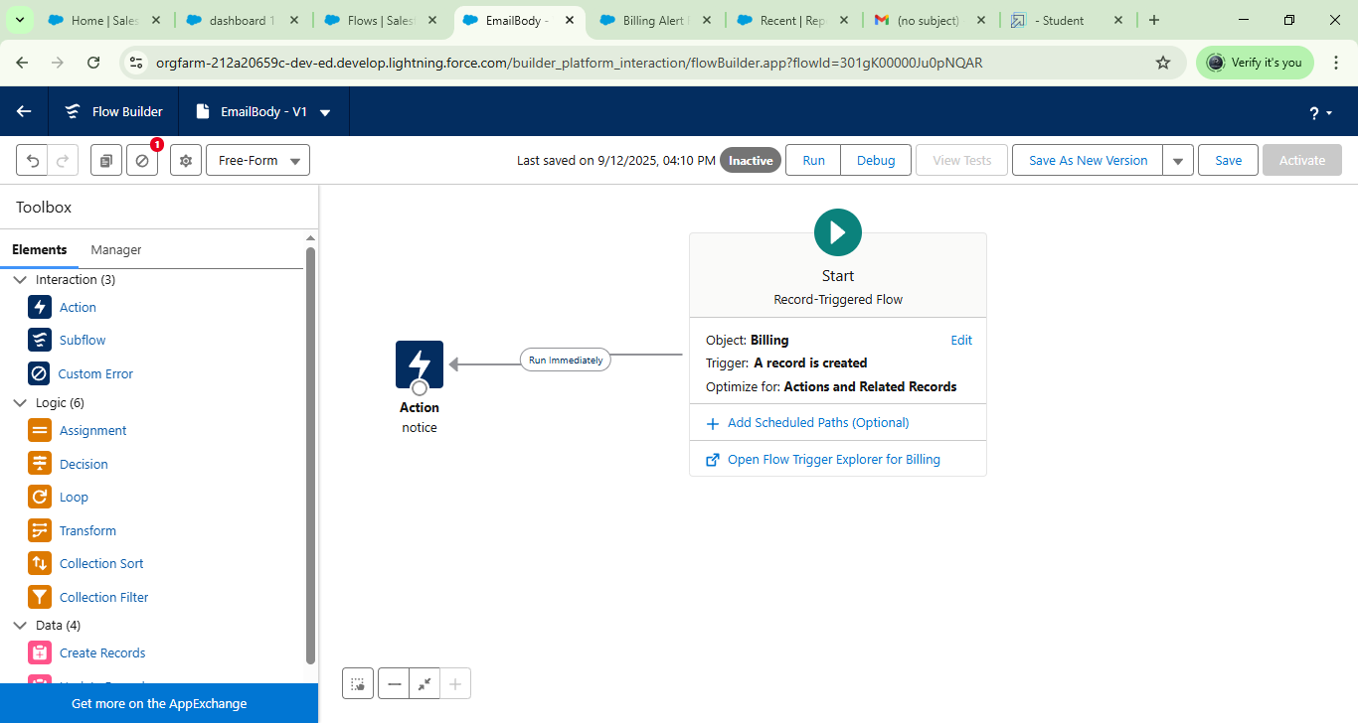

**Conclusion**

- The Jewel Management CRM project demonstrates practical Salesforce skills.

- Future improvements:

  - Enhanced UI customization.

  - Integration with external inventory systems.

  - Mobile app adaptation.

  - Advanced analytics with Tableau CRM.